DATA ANALYSIS PROJECT REPORT
Air Quality and Pollution Pattern Analysis
Project Title | Air Quality and Pollution Pattern Analysis
Student Name | Md. Arshad Islam, Zariful Islam Zahin
Student ID | 22-47050-1, 22-48598-3
Course / Section | CSC4162 / A
Instructor | MD. TANZEEM RAHAT
Date of Submission | 2 May 2026

1. Executive Summary
This project analyzes the UCI Air Quality Dataset to identify pollution patterns over time, during different parts of the day, and under different weather conditions. The dataset contains hourly air-quality measurements collected from March 2004 to April 2005, including pollutant concentrations, chemical sensor readings, temperature, relative humidity, and absolute humidity. The analysis used Pandas for loading, cleaning, grouping, and summarizing the data; NumPy for custom standardization, z-score outlier detection, percentiles, and comparative calculations; and Matplotlib for visualizing trends and relationships. The strongest findings are that pollution varies clearly by hour, rush periods show substantially higher average pollution than other hours, and the composite pollution score is strongly associated with CO, NOx, benzene, NO2, and multiple sensor readings. The work also shows that the original dataset required careful cleaning because missing values were encoded as -200 and several variables had notable missingness.

2. Introduction and Project Objectives
Air pollution is an important environmental and public-health issue because pollutant levels can change by time of day, traffic conditions, and weather. This project investigates a real monitoring dataset to understand when pollution levels are higher and which variables are most closely related to overall pollution. The goal is not to prove causation, but to use statistical summaries and visual analysis to identify meaningful patterns that can guide interpretation and further investigation.
Item | Your Content
Dataset name | UCI Air Quality Dataset (AirQualityUCI.csv)
Dataset source | UCI Machine Learning Repository - Air Quality Dataset
Main project goal | Clean and analyze hourly air-quality data to identify time-based pollution patterns, weather relationships, correlations, and unusual high-pollution records.
Research Question 1 | How do major pollutants and the composite pollution score vary over time and by hour of day?
Research Question 2 | How are temperature and humidity related to pollutant concentrations, especially benzene?
Research Question 3 | Which sensor readings and pollutant variables are most strongly correlated with the composite pollution score?
Research Question 4 | Are there unusual high-pollution records that should be treated as outliers?

3. Dataset Description
The dataset contains hourly observations from an air-quality monitoring system. Each row represents a date-time observation with pollutant measurements, sensor readings, and weather variables. The original file contained 9,471 rows and 17 columns, including two empty trailing columns created by separators in the CSV file. After cleaning and feature engineering, the analysis dataset contained 9,357 valid time-based records and 25 columns.

3.1 Basic Dataset Information
Property | Value
Number of rows | Original: 9,471; cleaned analysis rows: 9,357
Number of columns | Original: 17; cleaned/engineered analysis columns: 25
Data types present | Numeric, categorical, date/time, and text/date labels
Target or key variable(s) | Composite pollution_score; pollutant variables: co_gt, benzene_gt, nox_gt, no2_gt
Potential issues observed at first glance | Missing values encoded as -200, empty CSV columns, blank rows, and potential outliers in high-pollution records

3.2 Initial Observations
Initial inspection showed that the dataset was large enough for meaningful analysis and included more than 1,000 rows and more than six columns. The dataset included date and time fields, multiple numeric pollutant and sensor readings, and weather variables. A major issue was that missing values were not stored as standard blanks; they were encoded using -200. The notebook reported 16,701 instances of this missing-value marker before cleaning.

4. Data Cleaning and Preparation
The cleaning process focused on converting the raw CSV into a usable time-series analysis dataset. The notebook removed empty columns and blank rows, converted the dataset-specific missing marker to true missing values, parsed date and time fields, renamed variables into clearer Python-friendly names, and interpolated numeric variables so that trend and correlation analysis could be performed consistently.
Issue Found | Action Taken | Reason / Justification | Code Reference
Trailing empty columns | Dropped columns where all values were missing. | The original CSV had extra columns from trailing separators that did not contain usable information. | Data Cleaning cell
Blank or invalid date/time rows | Dropped rows missing Date or Time and parsed date-time values using day-first format. | Time-based analysis required valid chronological records. | Data Cleaning cell
Missing values encoded as -200 | Replaced -200 with NaN and interpolated numeric pollutant, sensor, and weather columns. | The UCI dataset uses -200 as a missing marker; interpolation preserves continuity for hourly analysis. | Data Cleaning cell
Unclear original column names | Renamed columns such as CO(GT), C6H6(GT), RH, and AH into co_gt, benzene_gt, relative_humidity, and absolute_humidity. | Clear names reduce confusion and support readable analysis code. | Data Cleaning cell

5. Feature Engineering
The notebook created several new variables from the cleaned data to support time-based grouping, category-based comparison, and outlier detection. These engineered features made it possible to answer the research questions more directly.
New Feature | How It Was Created | Why It Is Useful
datetime, date, month, hour, day_name | Date and Time fields were combined and parsed; then calendar features were extracted. | Supports monthly, hourly, and day-based trend analysis.
is_weekend | Created from datetime day-of-week values. | Allows comparison between weekend and weekday pollution patterns.
pollution_score | Standardized major pollutants and averaged their z-score values. | Creates one composite pollution measure from CO, benzene, NOx, and NO2.
pollution_level | Created using quartile bins of pollution_score. | Labels records as Low, Moderate, High, or Very high for easier interpretation.
pollution_z_score and is_pollution_outlier | Computed z-scores from pollution_score and flagged absolute z-scores greater than 3. | Identifies unusual high- or low-pollution observations.
temperature_band, humidity_band, rush_period | Binned temperature and humidity; classified hours into morning rush, evening rush, or other. | Supports comparison of pollution by weather condition and traffic-related time periods.

6. Analysis Methodology
The analysis was organized around the research questions rather than the order of code execution. Pandas was used to load the CSV, remove unusable rows and columns, replace missing markers, create time features, group records, calculate summary statistics, and save summary CSV outputs. NumPy was used for numerical computations such as z-score construction, percentile calculation, and a custom comparison of evening-rush pollution versus other hours. Matplotlib was used to create visualizations that directly support the analysis, including trend lines, bar charts, scatter plots, a correlation heatmap, and a rush-period distribution plot.
- Pandas: loading, cleaning, renaming columns, grouping by month/hour/rush period, calculating means, and producing summary tables.
- NumPy: creating z-scores, identifying outliers, computing the 90th percentile of pollution score, and calculating percentage difference between evening rush and other periods.
- Matplotlib: producing visual evidence for monthly trend, hourly pattern, weather-pollution relationship, correlations, and rush-period distribution.

7. Analysis and Visualizations
This section presents the main visual results and interpretations from the notebook. The figures are organized by research question and include brief interpretations focused on evidence and patterns.

7.1 Research Question 1: How does pollution vary over time?
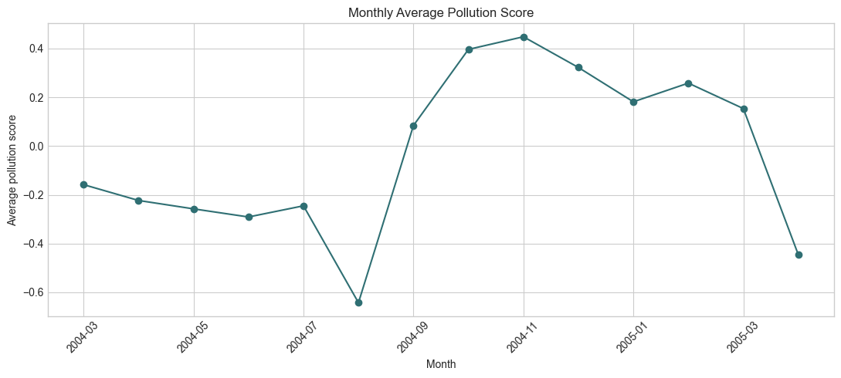
Figure 1. Monthly average pollution score.
Interpretation: The monthly trend chart shows that pollution levels changed noticeably across the study period rather than staying constant. This supports the idea that air quality should be evaluated as a time-dependent pattern. Month-level aggregation also reduces hourly noise and makes broader pollution trends easier to compare.

7.2 Research Question 1: Which hours show the highest pollution levels?
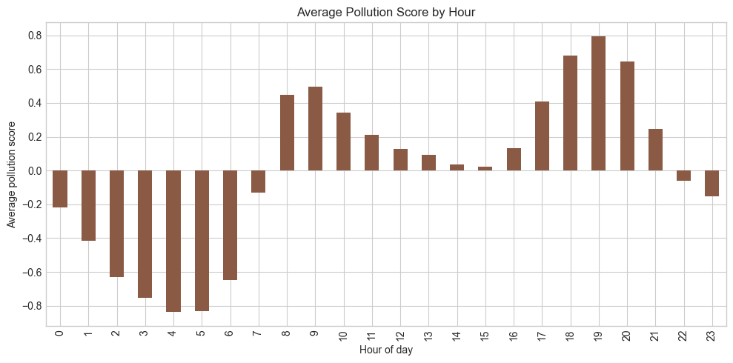
Figure 2. Average pollution score by hour of day.
Interpretation: The hourly bar chart compares the composite pollution score across all 24 hours. The pattern supports the notebook objective of identifying high-risk time periods. Higher pollution during rush-related hours is consistent with the later rush-period comparison and suggests that time of day is an important explanatory grouping variable.

7.3 Research Question 2: How are weather variables related to pollutant concentration?
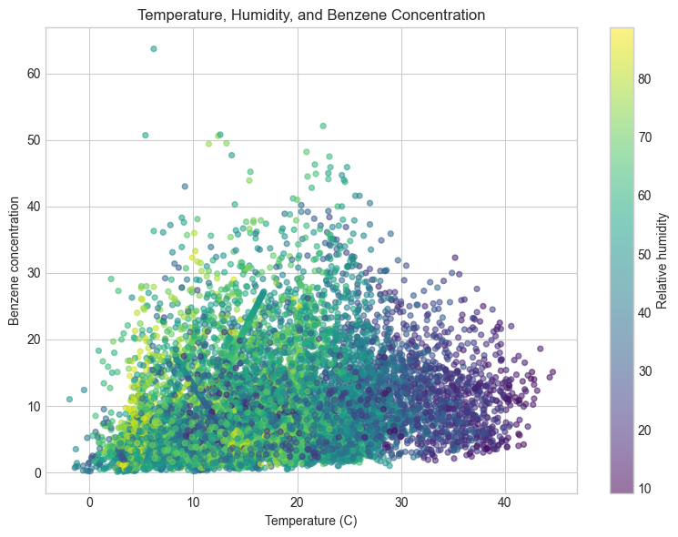
Figure 3. Temperature, humidity, and benzene concentration scatter plot.
Interpretation: The scatter plot compares temperature with benzene concentration while using relative humidity as a color scale. This visualization allows weather and pollutant behavior to be inspected together. The relationship is not purely linear, which supports using both visual inspection and correlation summaries rather than relying on a single statistic.

7.4 Research Question 3: Which variables are most strongly correlated?
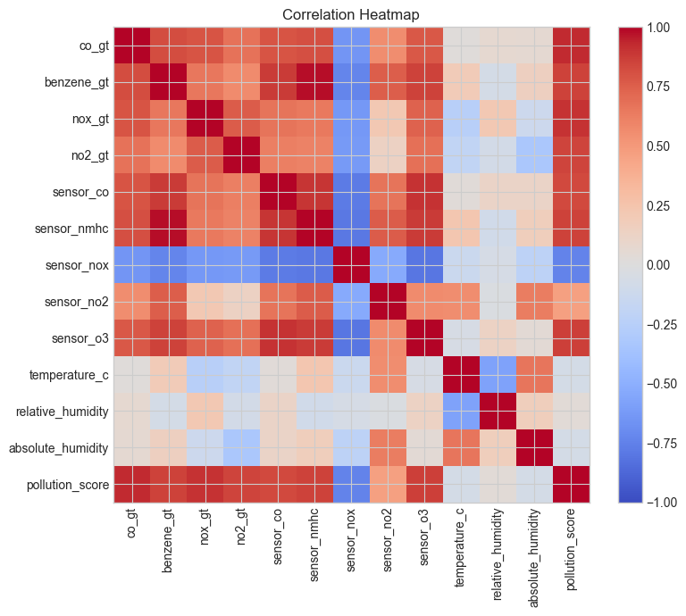
Figure 4. Correlation heatmap for pollutants, sensors, weather variables, and pollution score.
Interpretation: The correlation heatmap shows that the composite pollution score is strongly connected with several pollutant and sensor variables. The notebook output reported strong positive correlations with co_gt (0.927), nox_gt (0.906), sensor_o3 (0.861), benzene_gt (0.859), sensor_nmhc (0.858), no2_gt (0.850), and sensor_co (0.836). Weather variables were much weaker, while sensor_nox had a strong negative relationship with pollution_score (-0.742).

7.5 Research Question 4: How does pollution differ by rush period?
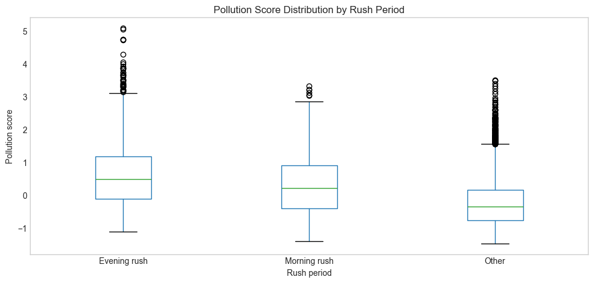
Figure 5. Pollution score distribution by rush period.
Interpretation: The boxplot compares pollution_score distributions for morning rush, evening rush, and other hours. The custom NumPy output showed that evening rush had a much higher average pollution score than other hours, with an estimated 374.04% increase relative to the other-period average. This makes rush-period classification one of the most useful engineered features in the project.

8. NumPy-Based Custom Computation
The notebook used NumPy for a meaningful custom computation beyond simple array conversion. It created z-scores for the composite pollution score, flagged outliers where the absolute z-score was greater than 3, computed the standard deviation and 90th percentile, and compared evening-rush pollution against other hours.
Component | Description
Computation used | Pollution z-score, outlier flag, 90th percentile, and evening-rush versus other-hours percentage change.
Purpose | To identify unusual pollution records and quantify how much pollution differs during an important engineered time period.
Formula or logic | pollution_z_score = (pollution_score - mean) / standard deviation; outliers have absolute z-score greater than 3. Evening change = (evening mean - other mean) / absolute(other mean) x 100.
Result / takeaway | The notebook identified 105 pollution outlier rows. It reported pollution_score standard deviation of 0.8854, 90th percentile of 1.2057, and evening-rush pollution about 374.04% higher than other hours.

9. Key Findings
- The raw dataset required meaningful cleaning before analysis because it included 16,701 missing-value markers coded as -200.
- After cleaning, the analysis used 9,357 hourly records from 10 March 2004 to 4 April 2005, which provided enough time coverage for monthly and hourly pollution comparisons.
- The composite pollution_score was strongly positively correlated with co_gt (0.927), nox_gt (0.906), benzene_gt (0.859), no2_gt (0.850), and several sensor variables.
- Hourly analysis showed that pollution patterns vary across the day, making hour of day and rush-period groupings useful for interpretation.
- Evening rush was a particularly important period: the custom NumPy calculation estimated evening-rush pollution to be about 374.04% higher than other hours.
- Outlier detection identified 105 records with unusually extreme pollution scores, showing that high-pollution events should be considered separately from typical observations.

10. Limitations
The dataset comes from one monitoring setup and one time period, so the results may not represent all cities, seasons, or monitoring conditions. Missing values were handled by interpolation, which is practical for hourly time-series analysis but may smooth extreme pollution events. The composite pollution score depends on the selected pollutant variables and the standardization method, so a different index design could produce slightly different rankings. Finally, correlation and visual association do not prove causation; high correlations show strong relationships in the dataset, but they do not prove that one variable directly causes another.

11. Conclusion
This project successfully cleaned and analyzed a real environmental dataset to identify air-quality patterns. The analysis showed that pollution varies over time and by hour, rush-period classifications provide a useful comparison, and major pollutants and sensor readings are strongly connected to the composite pollution score. The project also demonstrated that proper cleaning, feature engineering, NumPy-based computation, and visualization are all necessary for a complete data-analysis workflow. Future work could compare weekday and weekend patterns in more detail, evaluate seasonal effects, or use predictive modeling to estimate pollution levels from sensor and weather variables.

12. References / Dataset Source
UCI Machine Learning Repository. Air Quality Dataset. https://archive.ics.uci.edu/dataset/360/air+quality
Project notebook provided by the user: data_analysis_project.ipynb.

13. Appendix (Optional)
Output / File | Purpose
monthly_pollution_trend.csv | Monthly mean pollutant and pollution_score summaries.
hourly_pollution_pattern.csv | Hourly mean pollutant and pollution_score summaries.
rush_period_pollution.csv | Rush-period comparison table.
weather_pollution_summary.csv | Pollution summaries grouped by temperature and humidity bands.
pollution_correlations.csv | Correlation values between pollution_score and other variables.

Final Submission Checklist
☐ GitHub repository or Google Colab notebook link added to the instructor-provided Google Sheet.
☐ Project report attached as a separate file.
☐ Report includes dataset source, project objective, cleaning steps, feature engineering, analysis, visualizations, findings, limitations, and conclusion.
☐ Code uses Pandas, NumPy, and Matplotlib meaningfully.
☐ All bracketed placeholder text and helper notes have been replaced or deleted.

